Supplementary Information for “Graph-Enhanced Medical Question-Answering System Integrating Knowledge Graphs and Large Language Models”

Supplementary Tables
Table S1 Entity taxonomy of the medical knowledge graph
Entity type | Entity quantity | Example
Check | 3396 | Chest CT scan, bronchoscopy
Department | 54 | Internal Medicine, Respiratory Medicine
Disease | 8807 | Pulmonary alveolar proteinosis, whooping cough
Drug | 3829 | Erythromycin ethylsuccinate tablets, Baikejing syrup
Food | 4870 | Steamed egg custard, cherry tomatoes
Producer | 17202 | Chenpai Pharmaceuticals' Houshuning capsules
Symptom | 5998 | Cyanosis, chest pain, dyspnea, fatigue
Total | 44157 | Approximately 44,000 entities

Table S2 Knowledge graph relationship types
Relationship type | Relationship quantity | Example
acompany_with | 12029 | <Actinomycosis of lung, Complication, Subphrenic abscess>
belongs_to | 8844 | <ENT Department, Belongs to, Otolaryngology Department>
common_drug | 14649 | <Shiyiwei Jinse Pill, Common medication, Carbon disulfide poisoning>
recommand_drug | 59472 | <Asthmatic bronchitis, Recommended treatment, Xiaoqinglong Mixture>
drugs_of | 17139 | <Erythromycin ethylsuccinate tablets, Manufacturer, Guorui Erythromycin Ethylsuccinate Tablets>
do_eat | 22238 | <Carbon disulfide poisoning, Recommended food, Water spinach>
no_eat | 22247 | <Lobar pneumonia, Avoid food, Leek>
recommand_eat | 40236 | <Whooping cough, Recommended food, Steamed egg custard>
has_symptom | 54717 | <Pulmonary alveolar proteinosis, Symptom, Dyspnea>
need_check | 39599 | <Whooping cough, Required examination, Blood routine test>
Total | 291170 | Approximately 290,000 relationships

Table S3 Knowledge graph attribute type
Attribute type | Example
name | Benzene poisoning
desc | Benzene is obtained from coal tar distillation and petroleum cracking...
cause | Poisoning caused by inhalation of benzene vapor or skin contact...
prevent | For acute poisoning, immediately move the patient to fresh air...
cure_department | Emergency department
cure_lasttime | Typically 2–4 weeks depending on severity
cure_way | Medication, supportive therapy
cured_prob | 75%
easy_get | Common among shoemakers and chemical dye workers

Table S4 Medical question indicators
User intent | Medical interrogatives
Symptom | ['Symptom', 'Sign', 'Phenomenon', 'Syndrome', 'Manifestation']
Etiology | ['Reason', 'Cause', 'Why', 'How', 'How to', 'How can', 'Why', 'Can lead to', 'Cause']
Complication | ['Complications', 'Concurrent', 'In', 'Occur', 'Together', 'With', 'Co-occurrence']
Food | ['Diet', 'Drinking', 'Eat', 'Food', 'Meals', 'Diet', 'Drink', 'Dishes', 'Dietary restrictions', 'Supplements', 'Health products', 'Recipes', 'Cookbook', 'Edible','Supplements']
Medicine | ['Medicine', 'Drug', 'Medication', 'Capsule', 'Oral liquid', 'Tablets']
preventive measure | ['Prevention', 'Guard against', 'Resist', 'Defend against', 'Avoid', 'Evade', 'Escape', 'Bypass', 'Lest', 'Dodge', 'Avoid', 'Shun', 'Circumvent', 'How to avoid', 'How can avoid', 'How not to', 'How to prevent']
Treatment cycle | ['Cycle', 'How long', 'Duration', 'How much time', 'Days', 'Years', 'How many days', 'How many hours', 'Several hours', 'How many years']
Treatment method | ['How to treat', 'How to cure', 'Treatment method', 'Therapy', 'What to do', 'How to manage']
Probability of cure | ['Probability of cure', 'Chance of recovery', 'How likely to cure', 'Odds', 'Percentage', 'Proportion', 'Possibility', 'Can be treated', 'Curable', 'Treatable', 'Cure rate']
susceptible/vulnerable population | ['Susceptible population', 'Prone to infection', 'High-risk groups', 'Who', 'Which people', 'Infection', 'Contract', 'Develop']
Check | ['Examination', 'Test items', 'Detect', 'Check', 'Test', 'Diagnose']
Therapeutic Department | ['Which department', 'Belongs to', 'What department', 'Clinic']
Purpose | ['What it treats', 'What it cures', 'Usefulness', 'Purpose', 'Benefits', 'Uses', 'What it is used for', 'Needed for', 'Required']

Table S5 Top 10 scoring entities in diseases, examinations, departments, and symptoms based on degree centrality measurements
Diseases | Score | Examinations | Score | Departments | Score | Symptoms | Score
Acute urethritis | 66 | Routine blood test | 2127 | Dermatology | 647 | Abdominal pain | 1001
Primary hypertension | 65 | Urinalysis | 1315 | Orthopedics | 608 | Nausea | 969
Ulcerative colitis | 65 | Electrocardiogram | 1073 | TCM clinic | 487 | Fatigue | 776
Fatty liver | 64 | Stool test | 928 | Ophthalmology | 483 | Dyspnea | 751
Coronary disease | 63 | CT scan | 852 | Gastroenterology | 455 | Diarrhea | 672
Chronic pyelonephritis | 63 | Chest radiograph | 717 | General surgery | 419 | Coma | 416
Infertility | 63 | Cranial CT | 617 | Pediatric clinic | 414 | Nodules | 415
Ankylosing spondylitis | 63 | Smear test | 579 | Tumor surgery | 395 | Papules | 388
Acute glomerulonephritis | 63 | Blood test | 465 | Neurology | 387 | Low-grade fever | 386
Menopausal urinary tract infection | 63 | Cranial MRI | 459 | Gynecology | 339 | Cyanosis | 352

Table S6 Top 10 scoring entities in drugs and foods based on degree centrality measurements
Drugs | Score | Beneficial foods | Score | Harmful foods | Score
Levofloxacin hydrochloride caps | 708 | Eggs | 2135 | White liquor | 2754
Levofloxacin lactate tablets | 578 | Chicken | 1759 | Beer | 2085
Cefalexin capsules | 481 | Sesame | 1589 | White hyacinth | 1343
Xiaoaiping tablets | 419 | Sunflower seeds | 1317 | Almonds | 897
Qianglikang granules | 415 | Pumpkin seeds | 1299 | Preserved veg. | 836
Azithromycin tablets | 385 | Cashew nuts | 1062 | River snails | 828
Pingyangmycin hydrochloride for injection | 352 | Lotus seeds | 875 | Mung beans | 803
Erythromycin estolate tablets | 344 | Walnuts | 640 | Duck blood  (White duck) | 767
Prednisone acetate tablets | 338 | Duck eggs | 587 | Dried tofu skin | 758
Azathioprine tablets | 330 | Venison | 554 | Red beans | 732

Table S7 The analysis results of the k-nearest neighbor algorithm
Disease 1 | Disease 2 | Similarity score
Lung abscess | Pulmonary bullae | 1.00
Mercury poisoning | Iron poisoning | 1.00
Acute respiratory failure | Pediatric respiratory failure | 1.00
Acute lung abscess | Allergic purpura | 1.00
Acute myocardial infarction | Pregnancy-associated heart disease | 0.99
Hypertensive crisis | Elderly hypertensive crisis | 0.96
Migraine | Jueyin headache | 0.94
Obstructive emphysema | Influenza viral pneumonia | 0.89
Pigmentation disorders | Physical dermatoses | 0.85
Lung heat syndrome | Dyspnea syndrome | 0.82
Senile ventricular flutter/fibrillation | Pediatric myocarditis | 0.71
Calcific tendinitis | Hemochromatosis arthropathy | 0.62
Chronic laryngitis | Bagassosis | 0.55
Carcinoid | Otogenic hydrocephalus | 0.00
Arsenic poisoning | Flat warts | 0.00
Carbon tetrachloride poisoning | Pectus carinatum | 0.00

Table S8 Examples of medical questions
Numbers | Type | Examples
1 | disease_symptom | What are the symptoms of breast cancer?
2 | symptom_disease | What should I do if I have a runny nose recently?
3 | disease_cause | Why do some people suffer from insomnia?
4 | disease_acompany | What are the complications of insomnia?
5 | disease_not_food | What should people with insomnia not eat?
6 | disease_do_food | What to eat with tinnitus?
7 | food_not_disease | Who is the best person not to eat honey?
8 | food_do_disease | What are the benefits of goose meat?
9 | disease_drug | What medicine should I take for liver disease?
10 | drug_disease | What diseases can Banlan root granules cure?
11 | disease_check | How can meningitis be detected?
12 | check_disease | What can a complete blood count find?
13 | disease_prevent | How can kidney deficiency be prevented?
14 | disease_lasttime | How long does it take for a cold to heal?
15 | disease_cureway | How to treat high blood pressure?
16 | disease_cureprob | Can leukemia be cured?
17 | disease_easyget | Who is prone to high blood pressure?
18 | disease_desc | Diabetes

Supplementary Figures
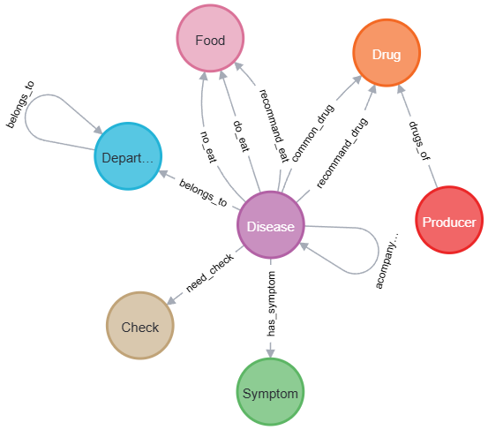
Figure S1 Metadata graph of medical knowledge graph.

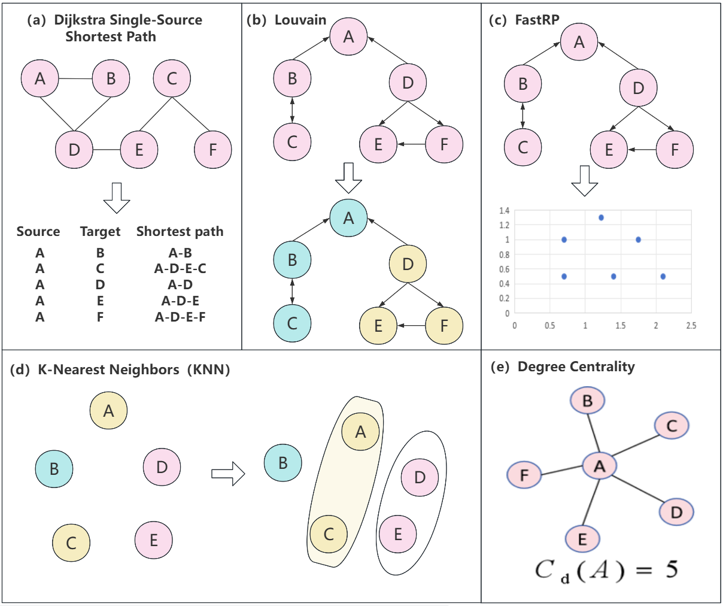
Figure S2 The diagram of the algorithms in GDS adopted in this study.

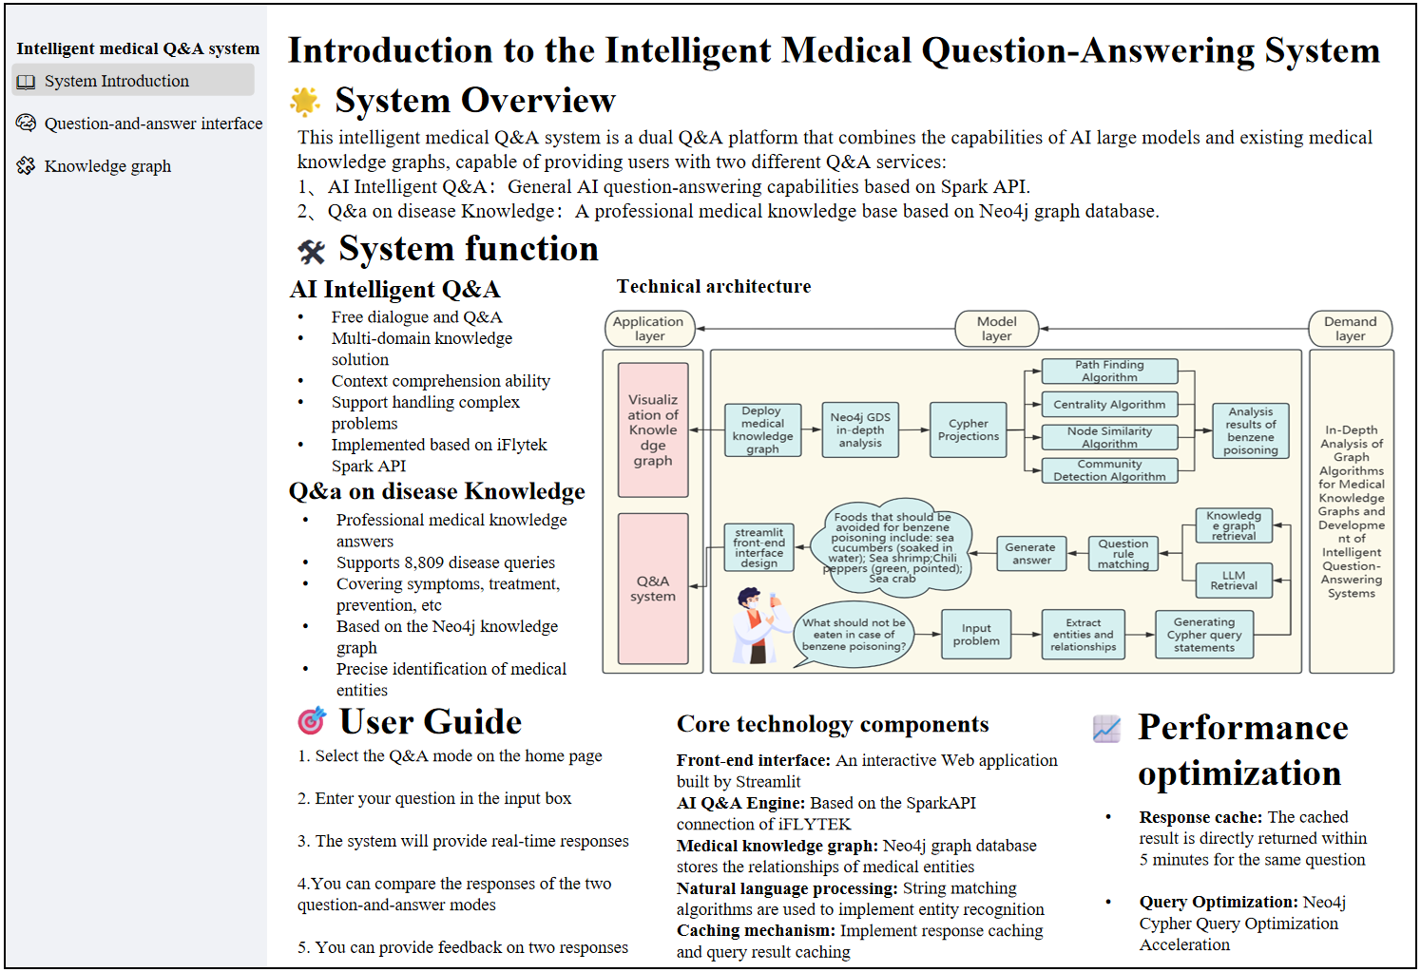
Figure S3 Introduction diagram of the system.
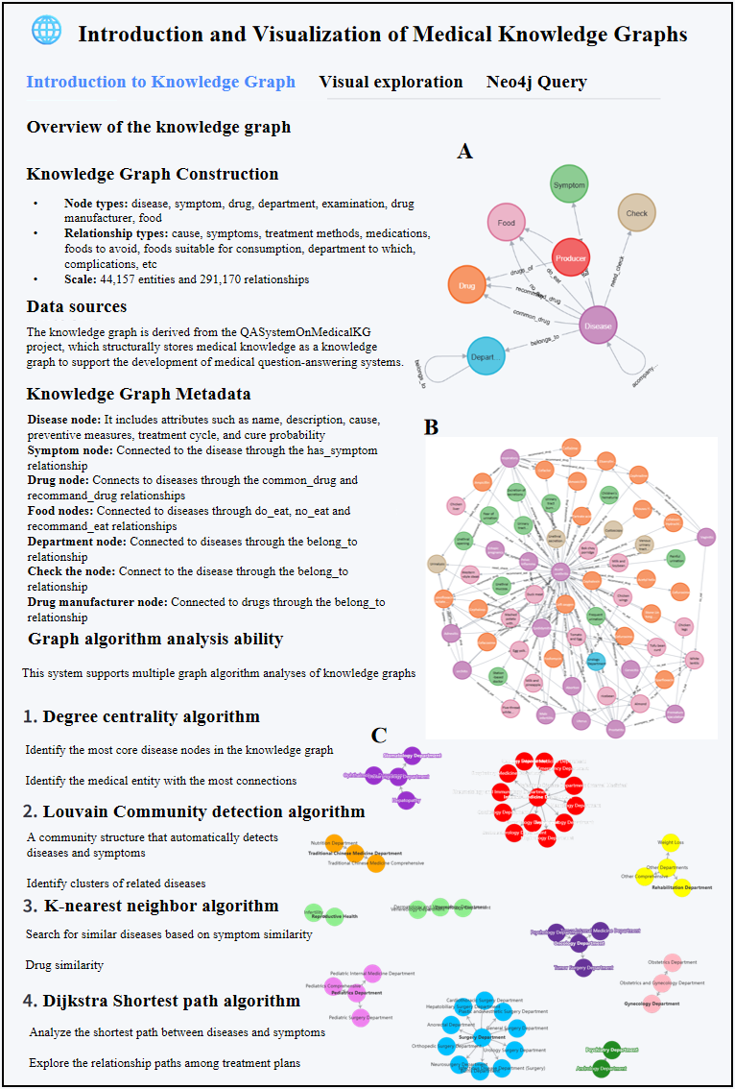
Figure S4 Introduction and visualization of medical knowledge graphs.

